Quality Assurance Report
2018 EOC SGPs

This document serves as the quality assurance report for 2018 EOC SGPs. The following descriptive statistics were used as part of the quality assurance process in evaluating the calculations for the 2018 EOC SGPs: the percentage of students who received SGPs, the correlation between median SGPs and mean prior scores, and the correlation between SGPs and Growth Targets.
Summary of findings:
1. | More than 90% of students received SGPs in 2018 9th-Grade Literature, American Literature, Algebra I and Geometry. The number of students taking Coordinate Algebra and Analytic Geometry have dropped significantly in 2018. Therefore, the percent of students received SGPs are lower in those subjects (72% and 77%, respectively. see Table 1). A sample list of districts with low percentage of students received SGPs are listed in Appendix 1 Table 1.1.
2. | The Mean SGPs all EOCs are approximately 50, with negligible differences that are accounted for by typical model fit. Those numbers are consistent with previous years (see Table 2).
3. | The correlation between Mean SGP and average prior achievement are overall consistent with previous years (see Table 3).
4. | There are strong correlations between current scale score and growth targets (-0.74 ≤ r_{xy} ≤ -0.90), and moderate negative correlations between SGPs and growth targets (-0.33 ≤ r_{xy} ≤ -0.24). These correlation values are expected as higher SGPs and scale scores in the current year would require less growth in the next year (see Table 4 and 5). Figures 1-2 also support this finding.

Table 1: Percent of Students who Received SGPs by Subject
SUBJECT  CODE | N SGP  2016 | N SCORE  2016 | % with SGP  2016 | N SGP  2017 | N SCORE  2017 | % with SGP  2017 | N SGP  2018 | N SCORE  2018 | % with SGP  2018
9th GRADE LIT | 124,732 | 141,546 | 88.12 % | 129,967 | 143,154 | 90.79 % | 128,348 | 140,674 | 91.24 %
AMERICAN LIT | 111,033 | 121,367 | 91.49 % | 117,081 | 126,239 | 92.75 % | 117,055 | 126,278 | 92.70 %
COORDINATE  ALGEBRA | 26,881 | 33,422 | 80.43 % | 24,811 | 29,308 | 84.66 % | 16,217 | 22,669 | 71.54 %
ANALYTIC  GEOMETRY | 93,257 | 102,627 | 90.87 % | 23,431 | 28,912 | 81.04 % | 20,563 | 26,547 | 77.46 %
ALGEBRA I | 91,267 | 109,417 | 83.41 % | 110,182 | 120,245 | 91.63 % | 113,601 | 124,915 | 90.95 %
GEOMETRY | 33,006 | 39,327 | 83.93 % | 92,874 | 105,557 | 87.98 % | 101,061 | 111,596 | 90.56 %

Table 2: Mean SGPs across Years – State Level
Subject | SIMEX MeanGP  2016 | Ranked  SIMEX MeanGP  2017 | Ranked  SIMEX MeanGP  2018
GRADE_9_LIT | 49.74 | 49.93 | 49.96
AMERICAN_LIT | 50.18 | 50.03 | 50.17
COORDINATE_ALGEBRA | 49.79 | 49.95 | 50.09
ANALYTIC_GEOMETRY | 49.80 | 49.81 | 49.83
ALGEBRA_I | 49.95 | 49.93 | 50.02
GEOMETRY | 49.72 | 49.71 | 49.39

Table 3: Correlations between Mean SGPs and Mean Standardized Prior Scores (N≥15) – School Level
 | School Level  Correlation  (2016) |  | School Level  Correlation  (2017) |  | School Level  Correlation  (2018)
Subject | Uncorrected MeanGP | SIMEX MeanGP | Uncorrected MeanGP | Ranked  SIMEX MeanGP | Uncorrected MeanGP | Ranked  SIMEX MeanGP
Grade 9 Lit | 0.55 | 0.42 | 0.40 | 0.24 | 0.44 | 0.25
American lit | 0.60 | 0.51 | 0.59 | 0.49 | 0.57 | 0.43
Coord. Algebra | 0.33 | 0.23 | 0.32 | 0.21 | 0.18 | 0.08
Ana. Geometry | 0.53 | 0.42 | 0.30 | 0.16 | 0.38 | 0.23
Algebra I | 0.35 | 0.24 | 0.37 | 0.28 | 0.37 | 0.28
Geometry | 0.59 | 0.49 | 0.48 | 0.36 | 0.41 | 0.27

Table 4: Correlations between Scale Score and Growth Targets
Subject | Scale Score vs.  Developing Target | Scale Score vs.  Proficient Target | Scale Score vs.  Distinguished Target
Grade 9 Lit | -0.83 | -0.89 | -0.74
Coord. Algebra | -0.82 | -0.90 | -0.81
Algebra I | -0.80 | -0.89 | -0.84

Table 5: Correlations between SGPs and Growth Targets
Subject | SGP vs.  Developing Target | SGP vs.  Proficient Target | SGP vs.  Distinguished Target
Grade 9 Lit | -0.26 | -0.26 | -0.24
Coord. Algebra | -0.29 | -0.30 | -0.28
Algebra I | -0.33 | -0.29 | -0.27

Figures 1-2 show examples of the relationship between Scale Score, SGPs and Growth Targets (which did not tend to differ across subject areas and grade levels). Students who demonstrated very high Scale Score/SGPs had an increased likelihood of receiving targets that were lower, which led to the negative correlations observed above in Table 4 and 5. In other words, Pearson correlation values are used to describe linear relationships, but the non-linearity of the data require Figures 1-2 to better understand the assocation between Scale Score/SGPs and Growth Targets. As would be expected across figures, the distinguished targets in were harder to attain than the developing targets. Both sets of findings were expected.

Figure 1: The scatter plot of Scale Score and Growth Targets in 9th Grade Literature
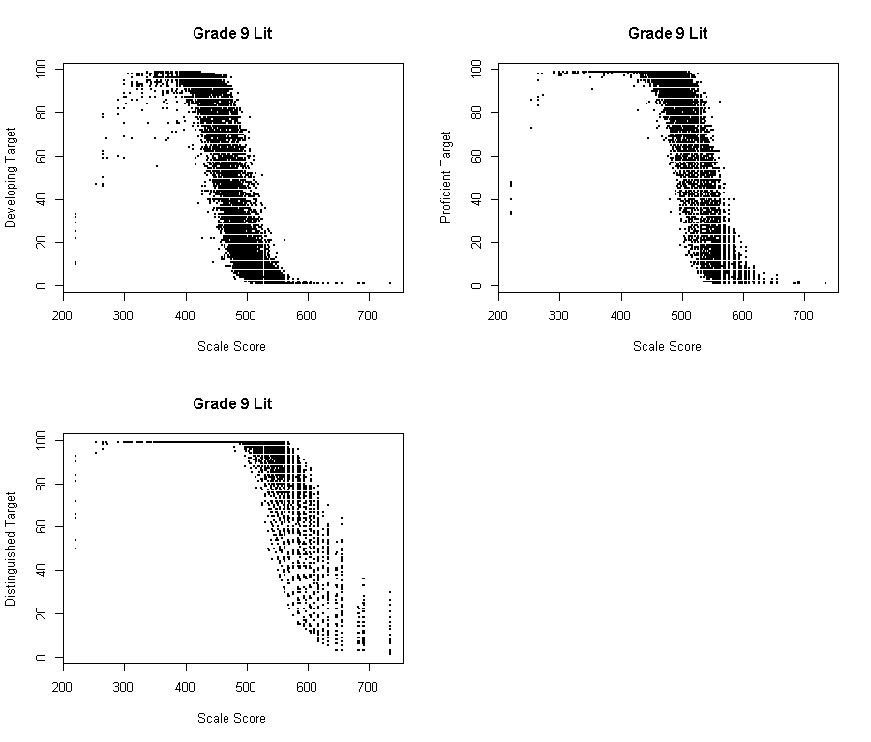
Figure 2: The scatter plot of SGP and Growth Targets in 9th Grade Literature
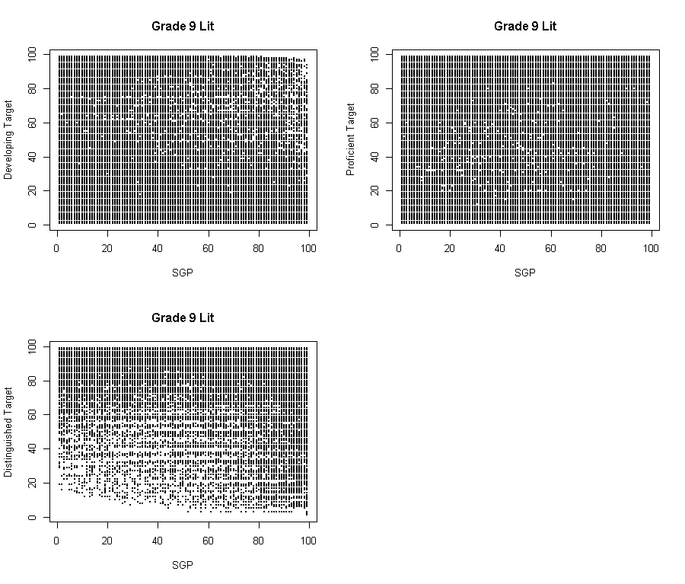
Appendix A
Table 1.1: A Sample of Districts with Low % received SGP
SUBJECT  CODE | SYSTEM  ID | SYSTEM  NAME | N  SGP | N  TOTAL | %Received  SGP | Why aren’t those students getting SGPs?
ANALYTIC  GEOMETRY | 631 | Clayton County | 0 | 60 | 0.00% | Some students were in Algebra I and Geometry math track prior to 2018
ANALYTIC  GEOMETRY | 761 | Atlanta Public Schools | 0 | 35 | 0.00% | Some students were in Algebra I and Geometry math track prior to 2018
COORDINATE  ALGEBRA | 675 | Henry County | 0 | 96 | 0.00% | Some students took Coordinate Algebra in 12th Grade
GEOMETRY | 693 | Lumpkin County | 10 | 268 | 3.73% | This district was offering Coordinate Algebra and Analytic Geometry track in prior years
GEOMETRY | 786 | Social Circle City | 9 | 141 | 6.38% | This district was offering Coordinate Algebra and Analytic Geometry track in prior years
GEOMETRY | 685 | Lamar County | 48 | 229 | 20.96% | This district was offering Coordinate Algebra and Analytic Geometry track in prior years
COORDINATE  ALGEBRA | 891 | Department of  Juvenile Justice | 24 | 85 | 28.24% | Missing Prior scores
ANALYTIC  GEOMETRY | 891 | Department of  Juvenile Justice | 24 | 72 | 33.33% | Missing Prior scores
GEOMETRY | 7820119 | State Charter Schools  Graduation Achievement  Center Charter High School | 67 | 167 | 40.12% | This charter school was offering Coordinate Algebra and Analytic Geometry track in prior years
GRADE 9 LIT | 626 | Chattahoochee County | 59 | 137 | 43.07% | Many of those students are new to the state
ALGEBRA I | 626 | Chattahoochee County | 53 | 122 | 43.44% | Many of those students are new to the state
AMERICAN LIT | 626 | Chattahoochee County | 38 | 65 | 58.46% | Many of those students are new to the state
GEOMETRY | 626 | Chattahoochee County | 68 | 114 | 59.65% | Many of those students are new to the state

